SAMD21 M0 32-bit ARM Cortex M0 (Arduino M0 variant)

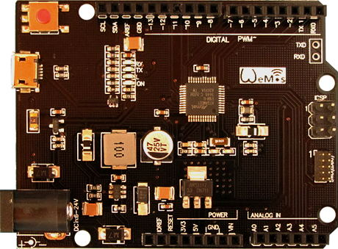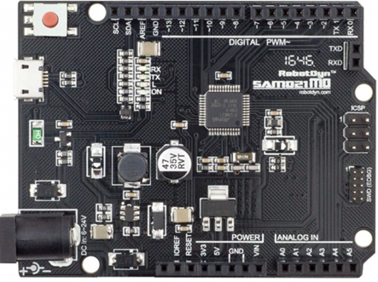

**Arduino M0 Board (Discontinued)**

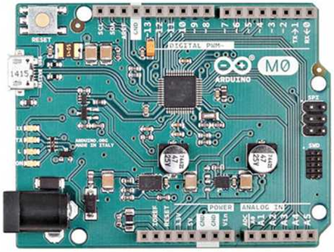[1]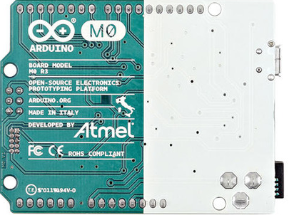[2]

Product Specifications[3]

|  |  |
| --- | --- |
| Microcontroller | ATSAMD21G18 48pins LQFP |
| Power Out | 3.3V-800mA |
| Power IN. USB | 5V |
| Power IN. VIN/DC Jack | 4-12V |
| Power Consumption | 3.3V 220mA |
| Logic Level | 3.3V |
| USB | Micro USB |
| Clock Frequency | 48MHz |
| Operating Supply Voltage | 3.3V |
| GPI/O | 27 |
| Digital I/O | 21(12-PWM) |
| Analog I/O | 6 |
| Data RAM Type/Size | 32Kb |
| Data ROM Type/Size | 256Kb |
| Interface Type | ISP |
| Operating temperature | −40С°/+85С° |
| Length×Width | 53.34×68.58mm |

Setting Up Arduino

Install Arduino SAMD Boards[4]

To install the Arduino SAMD board definitions, navigate to your board manager (**Tools** > **Board** > **Boards Manager...**) from the top menu. In the Boards Manager dialog box, type M0 in the search or filter field, find an entry for **Arduino SAMD Boards (32-bits ARM Cortex-M0+)**. Select it, and install the latest version (recently updated to 1.8.57).

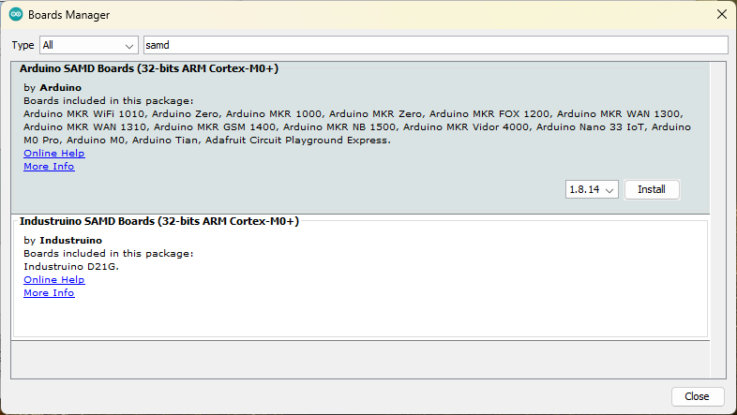Once installed, Arduino-blue "Installed" text should appear next to the SAMD boards list entry.

Select the Board and Serial Port

From the top Arduino IDE menu, select **Tools → Board → Arduino/Genuino Zero (Native USB Port)** as shown in the image below.

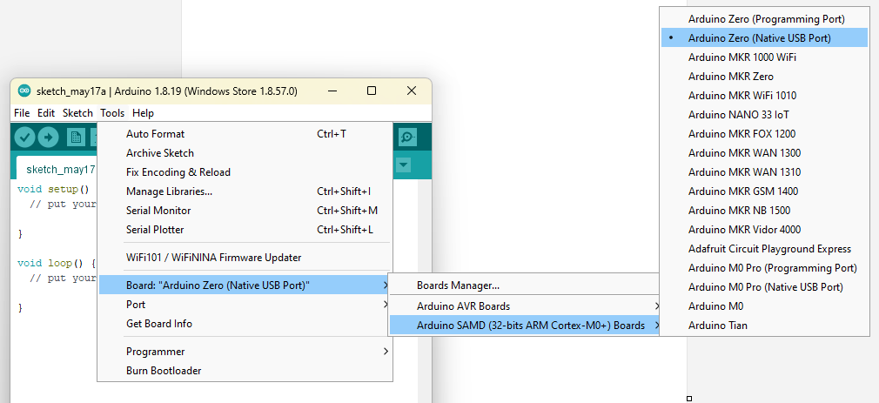

Finally, select the correct serial port under **Tools → Port** also from the top menu. The port menu may magically know which of your ports (if you have more than one) are the SAMD21 board. On a Windows machine, the serial port should come in the form of "COM#". On a Mac or Linux machine, the port will look like "/dev/cu.usbmodem####".

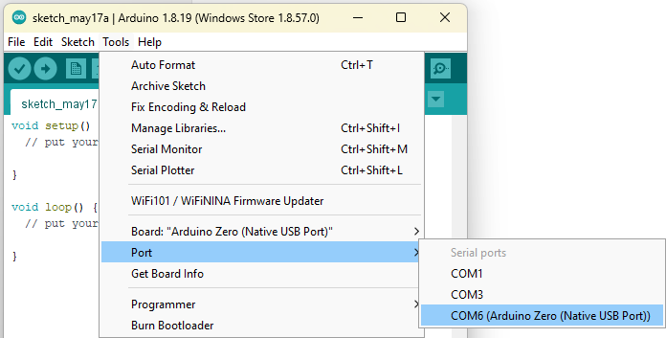

With the correct board and port selected as described above, the blink example sketch from the IDE can be loaded to the board to blink the on-board L LED.

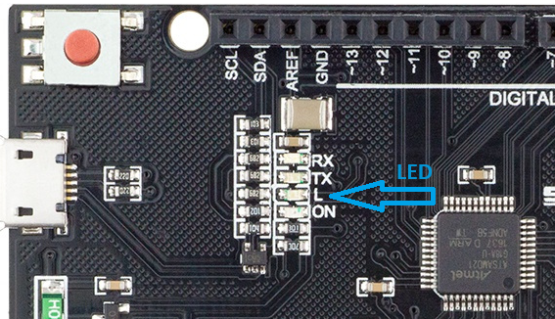

In the [Arduino](https://startingelectronics.org/articles/arduino/wemos-arduino-m0/) IDE, open the blink sketch from the top menu under **File → Examples → 01.Basics → Blink** and load it to the WeMos M0 board.

If the correct board and port is selected and the board is working, the L LED will start blinking.

**Programming the Serial Ports[5]**

Unlike [Arduino](https://startingelectronics.org/articles/arduino/wemos-arduino-m0/) boards such as the Arduino Uno or even an [Arduino M0 Pro](https://startingelectronics.org/articles/arduino/wemos-arduino-m0/) using the Programming port, the [Arduino M0](https://startingelectronics.org/articles/arduino/wemos-arduino-m0/) or WeMos variant does not feed the default serial port into a chip on the board that controls the USB programming. This means that programs or sketches that use the default Serial port will not work through the USB connection. The USB connection on [Arduino M0](https://startingelectronics.org/articles/arduino/wemos-arduino-m0/) and compatible boards is the native USB connection of the main microcontroller on the board.

What the above means is that all software that uses the **Serial** object must be changed to use the **SerialUSB** object instead. Alternatively, a USB to 3.3V TTL device such as those based on the FTDI chip can be used to connect to one of the other serial ports on the board. If a USB to TTL converter is used, then an external serial program, such as Tera Term on Windows or minicom on Linux, will need to be used instead of the [Arduino](https://startingelectronics.org/articles/arduino/wemos-arduino-m0/) IDE Serial Monitor.

The image below shows how the serial ports on the WeMos SAMD21 M0 map to serial port objects in software, an explanation of each port follows.

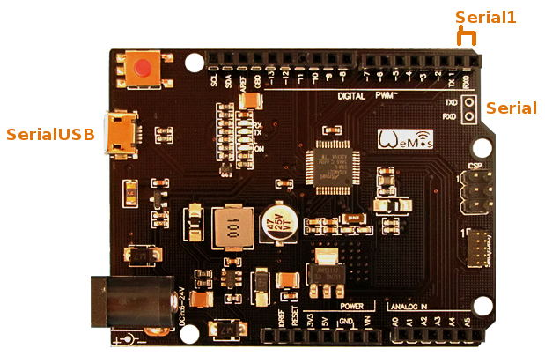

**SerialUSB**

The SerialUSB object is used to send and receive serial data over the USB link, e.g. to the [Arduino](https://startingelectronics.org/articles/arduino/wemos-arduino-m0/) IDE Serial Monitor window. Sketches that normally use the Serial Monitor window with other Arduino boards must be modified to use SerialUSB when using [Arduino M0](https://startingelectronics.org/articles/arduino/wemos-arduino-m0/) compatible boards.

SerialUSB example code:

SerialUSB.begin(9600);

while (!SerialUSB);

SerialUSB.println("Test SerialUSB");

**Serial**

The Serial object in a sketch uses the TXD and RXD pins at the end of the board as shown in the above image. A USB to TTL (3.3V) converter cable can be used to connect to this port. When a converter is used, TX or TXD (transmit) of the converter connects to RX or RXD (receive) on the [Arduino](https://startingelectronics.org/articles/arduino/wemos-arduino-m0/). RX or RXD of the converter connects to TX or TXD on the [Arduino](https://startingelectronics.org/articles/arduino/wemos-arduino-m0/).

Serial example code:

Serial.begin(9600);

while (!Serial);

Serial.println("Test Serial");

**Serial1**

Digital pins 0 and 1 connect to RX and TX serial port pins. The Serial1 object in a sketch uses these pins. The same USB to TTL converter as described above can be used on these pins.

Serial1 example code:

Serial1.begin(9600);

while (!Serial1);

Serial1.println("Test Serial1");

**WeMos SAMD21 M0 Serial Port Sketch**

The above code snippets are shown below in an Arduino sketch.

// Serial Ports on the WeMos M0 (Arduino M0 variant)

// https://startinglectronics.org/articles/arduino/wemos-arduino-m0/

// 30 May 2018 | W.A. Smith

void setup() {

// Virtual USB COM Port (Native USB)

SerialUSB.begin(9600);

while (!SerialUSB);

SerialUSB.println("Test SerialUSB");

// TXD and RXD pins at end of board

Serial.begin(9600);

while (!Serial);

Serial.println("Test Serial");

// TX and RX pins on digital pins 0 and 1

Serial1.begin(9600);

while (!Serial1);

Serial1.println("Test Serial1");

}

void loop() {

// Square wave for oscilloscope testing

//Serial.write('U');

}

The above code was tested using a USB to TTL converter and external terminal program. Sending a capital 'U', as shown in the commented out code in loop() produces a square wave on TX or TXD pin of the [Arduino](https://startingelectronics.org/articles/arduino/wemos-arduino-m0/) that can be tested with an oscilloscope. This works on Serial or Serial1.

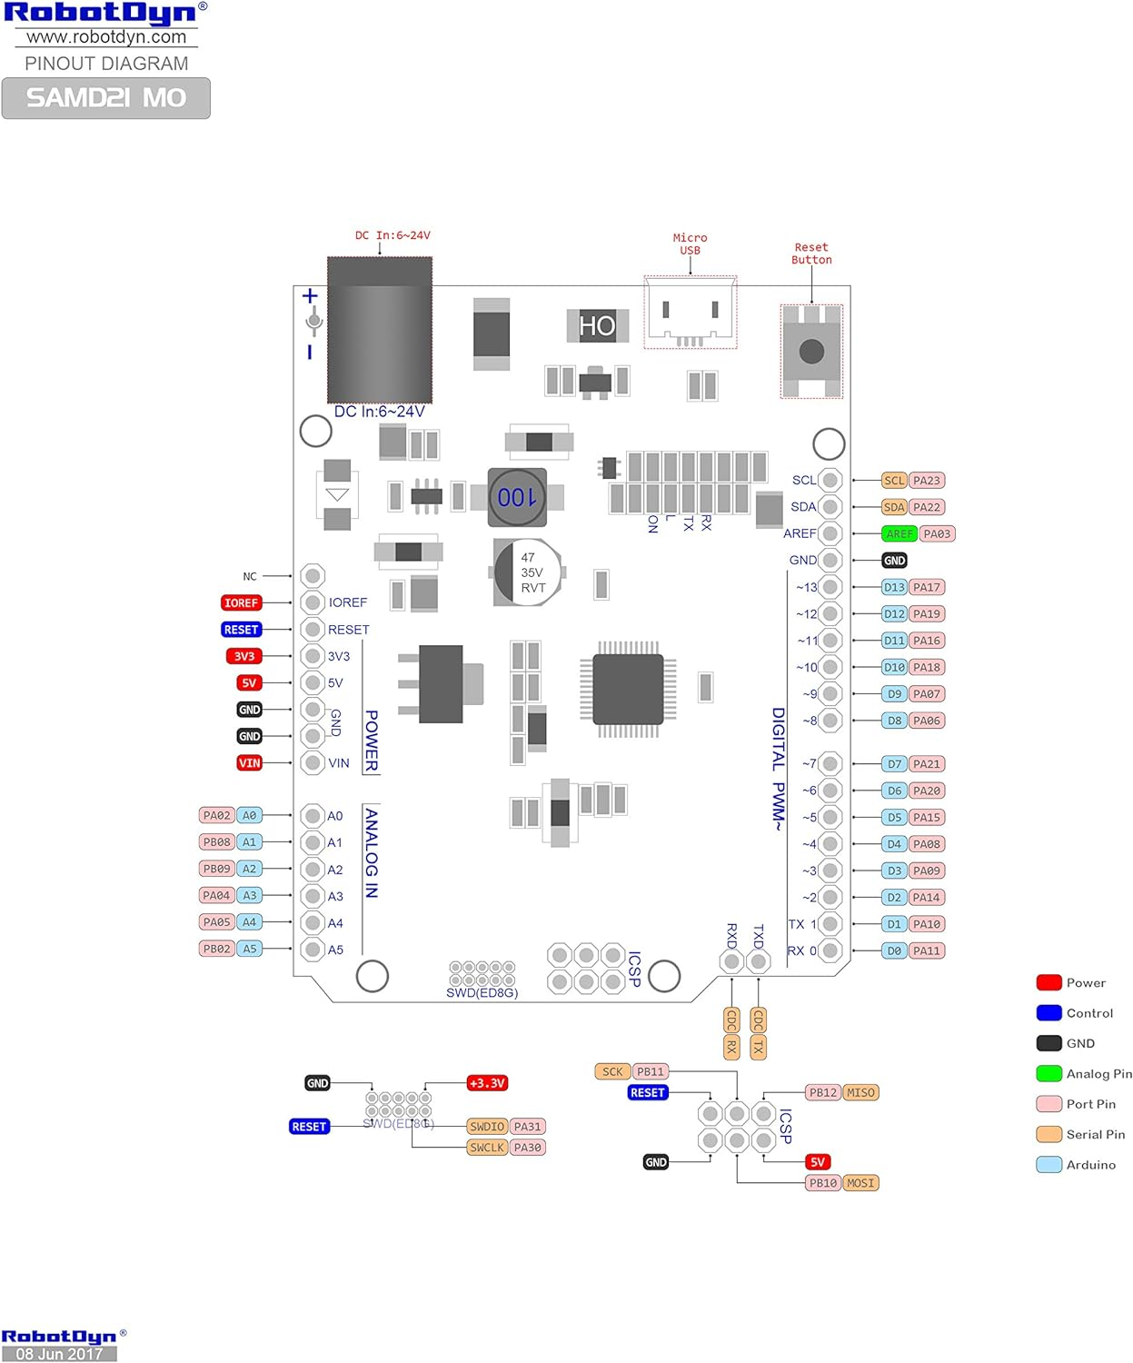https://m.media-amazon.com/images/I/81WM4pZQ-KL._AC_SL1500_.jpg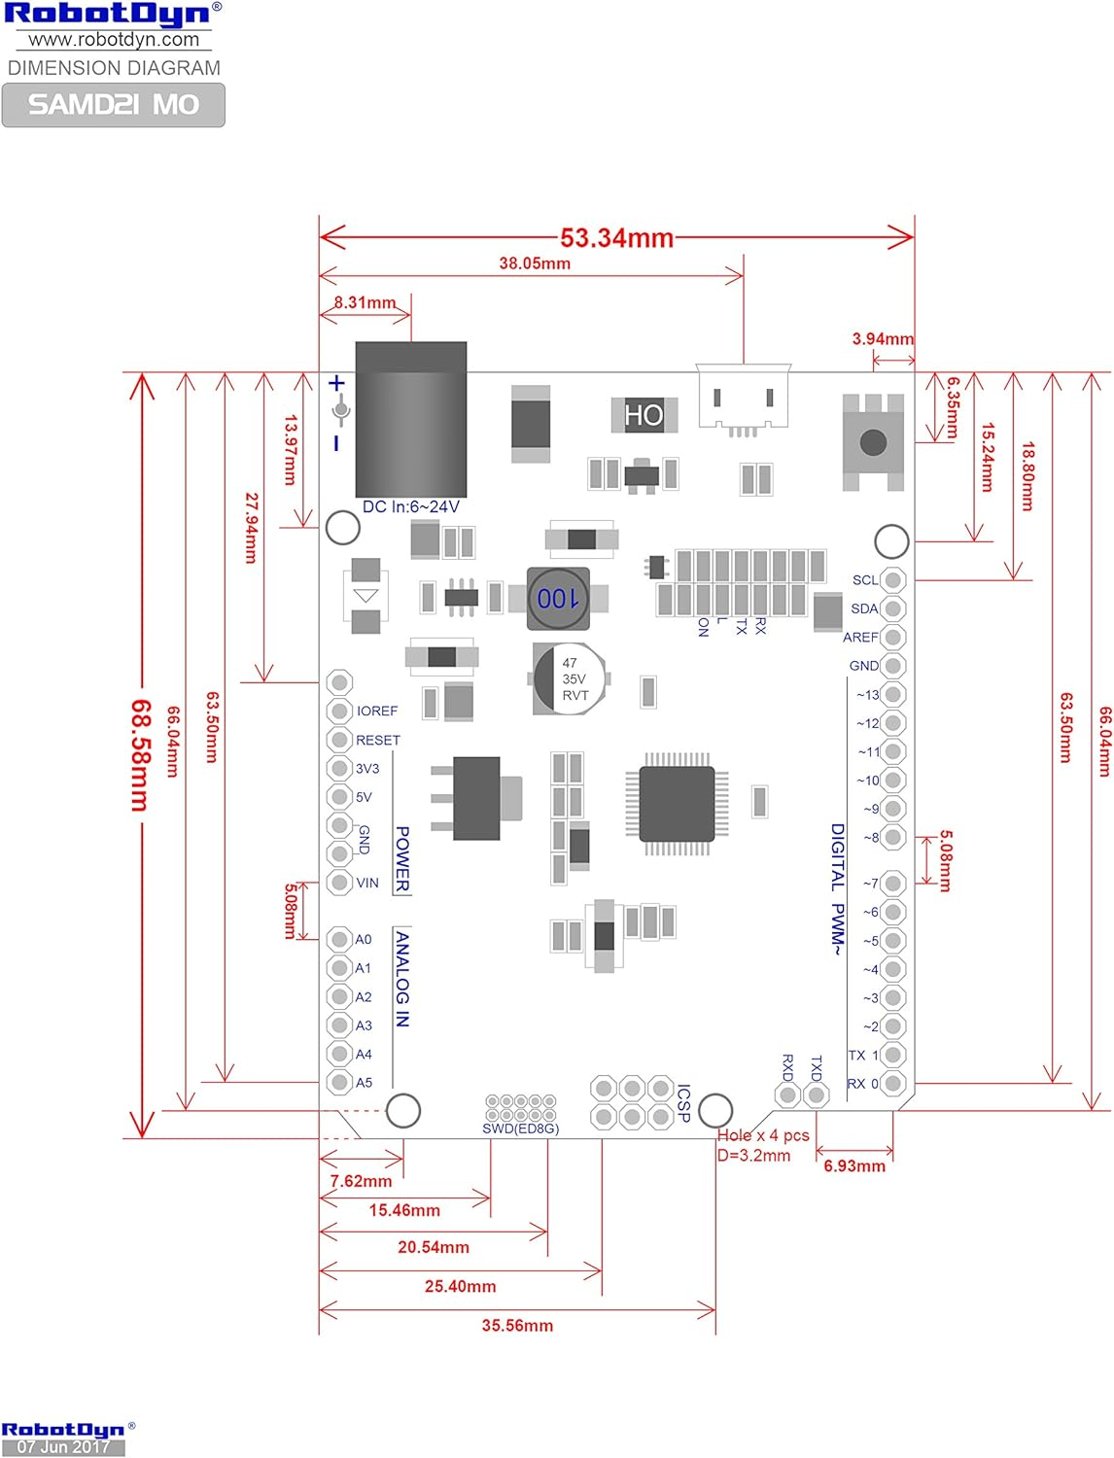https://m.media-amazon.com/images/I/81c3KkBPpdL._AC_SL1500_.jpg

1. https://docs.arduino.cc/retired/boards/arduino-m0/
2. https://dfimg.dfrobot.com/Arduino-M0-back_564x376.jpg?imageView2/1/w/564/h/376
3. https://robotdyn.com/samd21-m0.html
4. https://learn.sparkfun.com/tutorials/samd21-minidev-breakout-hookup-guide/setting-up-arduino
5. https://startingelectronics.org/articles/arduino/wemos-arduino-m0/